Breathitt Veterinary Center

Poultry Dropping Evaluation
Normal Droppings – Chickens
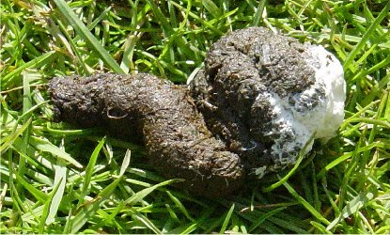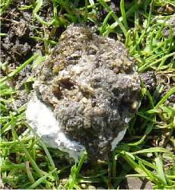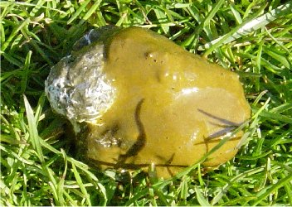
Normal Well Formed with white cap Normal Soft with white cap Normal cecal dropping
light to dark green to brown
Slightly abnormal – start being concerned if seeing in over 10-20 % or droppings
Interpret with clinical signs in mind; May warrant fecal testing.
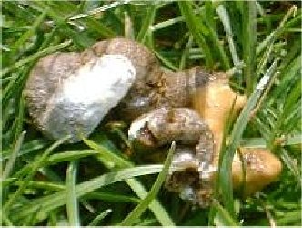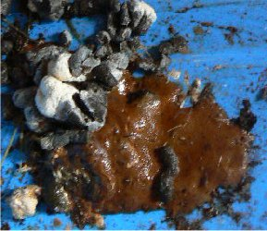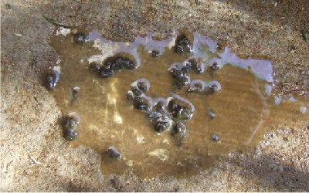
Normal with caramel colored foam Normal with orange/brown/red mucus Increased water passage
Occurs with increased water consumption or malabsorption
Abnormal – start being concerned when these are noted more than occasionally
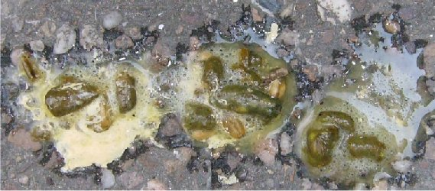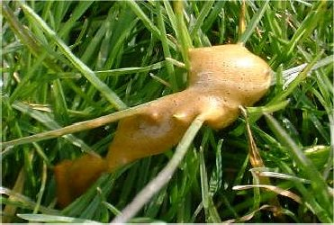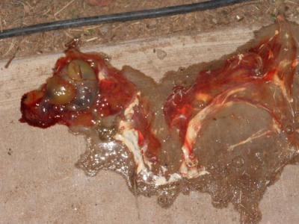
Increased passage of feed Caramel Foamy Dropping Bloody Dropping
Seen with enteritis Cecal origin Fecal exam for coccidiosis
PO Box 2000 101 MSU Drive Hopkinsville, KY 42241-2000 | Office: 270-886-3959 | Fax: 270-886-4295 | http://breathitt.murraystate.edu 7/19 BH

